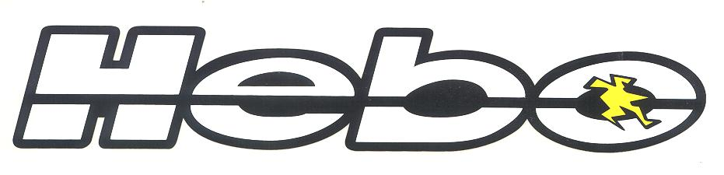
HYDRAULIC CLUTCH KIT, UNIVERSAL MODEL

Part Number HR8900101

This product has been studied and designed for improving the clutch operation of motorcycles originally equipped with a cable type clutch. With this product, you should realize the following improvements:
- A substantial reduction of the effort required to pull in the clutch lever.
- Elimination of the constant need to adjust the clutch cable due to the expansion and contraction of the clutch plates during sustained operation. This adjustment is realized automatically with the hydraulic type system giving the best position of the clutch lever at all times, under all conditions of operation.

This kit is designed to mount to a variety of motorcycles made by different manufacturers. It will be necessary to combine and adjust specific pieces of the system for the best operation of your specific machine. A selection of different pieces has been included in this kit to achieve the correct installation and operation for each application.

MOUNTING INSTRUCTIONS
1- Remove the clutch lever, and original cable from the motorcycle.
2- Find the best location for mounting of the slave cylinder in relation to alignment with the clutch actuation lever on the engine.
3- Mount the master cylinder to the handlebar and locate the best routing for the hydraulic hose. (Normally, this would be the same routing as the original cable.)
NOTE: On some motorcycles, it is necessary to disconnect the hydraulic hose from the system to route it properly through the chassis. If this is necessary: Pull the clutch lever all the way to the handlebar and tighten the center bolt to keep it in place and seal the master cylinder system. Remove the hose from the master cylinder taking care not to damage the sealing washers. It will probably be necessary to bleed the system after installation.
- Select the pieces best suitable for your application. See the list of parts and photos on page two.
- Remove the rear dust boot, and red cap from the rear of the slave cylinder (A & B in figure below) Pull the cable out from the interior of the slave cylinder and cable housing (D in figure below). Shorten the cable housing to the length necessary for your application and suitable for which cable-housing end that you have selected.
NOTE: Be careful not to position the slave cylinder in a way that will not allow access to the bleeder nipple, or prevent future maintenance of this component. Be careful to keep the slave cylinder, cable, and hydraulic hose isolated from extreme heat sources.
- Replace the cable into the cylinder (D) and cable housing (M). Install the bushing and cable end that you have selected.
- Adjust these components for proper fit, but do not tighten them at this time.
- ADJUSTMENT:
- Set the cable tension adjuster at 8 to 10mm as shown in the photo below. (G)
- Draw the cable into the slave bore until the cable end and end-bushing (C) are inside approximately 35mm from the rear of the housing.
- Put the clutch master cylinder into the final position that you have selected and tighten the clamp bolts.
- Tighten all components of the system. It is important that everything be very tight.
- Adjust the tensioner sleeve (G) to achieve an interior distance of 25 to 28mm from the end of the cable and the slave housing (C)
VERY IMPORTANT NOTE: Included in the kit is a RIVET. This rivet is for measuring the adjustment distance of the piston in the interior bore of the slave cylinder. See figure 12 on page 2. The distance from the head of the rivet to the tip is 28mm. The rivet is placed into the rear of the slave bore and when the head is rested on the rear outside surface of the slave housing, the rivet tip should be touching the cable end. Adjust the tensioner sleeve until this measurement is achieved. Action of the clutch varies depending on application. Test for proper operation of the components and make adjustments as necessary.
- Tighten the jamb nut on the tensioner sleeve.
- Re-install the dust boot and red end cap on the rear of the slave cylinder. (A & B)

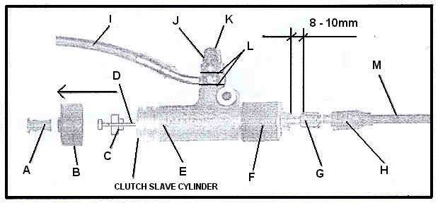
COMPONENTS IN SCHEMATIC:
A: End cap B: Dust boot C: Cable end-bushing D: Cable E: Slave cylinder housing F: Rubber protection tube G: Tensioner sleeve H: Housing dust boot I: Hydraulic hose J: Banjo bolt/bleeder valve K: Rubber bleeder valve dust cap L: Hydraulic high pressure sealing washers M: Cable housing

